Calculating photon catch efficiency of cones
Short guide to calculating photoisomerisation from cone spectra and measured power of LED emitted light.
Photoisomerisation is the change in conformation of the retinal molecule from cis to trans form. For that, the molecule needs to absorb a photon. Whether or not it happens depends on the molecule's sensitivity to light of a particular wavelength λ.
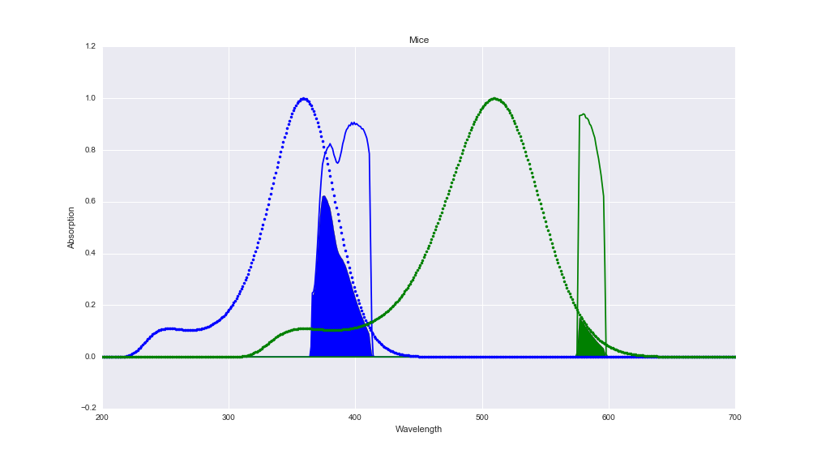

Above: example of two cone spectra from a mouse (dotted lines), and two spectra of LEDs (solid lines) that were passed through an optical bandpass filter – i.e. the measured effective spectrum of each LED as it hits the sample. If you measured emission spectra after filtering LED light, normalise it to 1. In the example above LED spectra were measured, normalised to 1 and then multiplied with the filter (which means they are not normalized to 1 in the end..). The cone spectra (absorption) give the relative (i.e. peak-normalised) sensitivity of each cone as a function of wavelength.
For the purposes of our calculation, we take opsin absorption to mean the probability of the pigment photoisomerisation when the photon of the corresponding wavelength hits the outer segment of a cone. Since some photons will hit the cone but miss any opsins (i.e. go straight through) a linear correction (probability of photoisomerisation at the peak of the cone spectrum) is applied to calculate the absolute number of photoisomerisations. For simplicity, we assume this probability (p_{iso}) is wavelength independent and approximately 67% (0.67).
Thus the number of photoisomerisations per (one) cone per second (nPh_{Iso} s⁻¹), which is equivalent to the “R*” value typically given is:
nPh_{Iso} s⁻¹= A_{cone} / A_{total} * nPh_{total} s⁻¹ *p_{iso}
where A_{cone} is the area of a single cone outer segment, A_{total} is the total area of the stimulus, nPh_{total} s⁻¹ is the total number of photons of the full-sized stimulus and p_{iso} is the probability of photoisomerisation if a photon hits a cone outer segment.

I. Calculating the number of photons in the stimulus per second (Φp)
1. X - Reading of the photometer - total energy absorbed by the photometer. Equivalent to energy flux. Measured in nanoWatts (nW). Make sure that the entire light spot hits the detector.
Convert nW to W:
X (nW) * 10⁻⁹ = Φ, Energy Flux (W)
2. Convert this to Energy Flux to electronVolts per second (eV/s). 1 eV is equivalent to approx. 1.6*10⁻¹⁹ Joules, therefore multiply by reciprocal of this number
Φ(W) * 6.24*10¹⁸ = Φ(eV/s)
3. Calculate the wavelength-dependent Photon Energy, Q(eV):
Speed of Light, c (299,792,458 m/s) * Planck's Constant (4.135 667*10⁻¹⁵ eV*s) / Wavelength (nm) = Q(eV)
4. Divide Energy Flux by the Photon Energy to get the Photon Flux (photons per second):
Φp (Photon Flux) = Φ(eV/s) / Q(eV)
This measurement is per photosensor unit area as noted in I.1.
II. Calculating the proportion of the light spot covered by the cone (f_{cone}).
1. Measure the radius of the light-spot in nanometres (nm): r_{total}. Square it and multiply by π to get the area of the spot (A_{total}):
A _{total} = r_{total}² * π
2. Calculate the area of the outer segment of a single cone.
e.g. A_{cone} = r_{cone}² * π
3. Divide the two areas to get the fraction of the light-spot that is taken up by a single cone (f_{cone}). Make sure they are in the same units so all units cancel.
f_{cone} = A _{cone} / A _{total}
III. Calculating the wavelength-dependent factor (fλ)
1. Multiply the output LED spectrum by the corresponding cone spectrum (solid colour in the Figure).
LED(λ) * CONE(λ)
2. Take the integral over the area of the resulting curve.
∫( LED(λ) * CONE(λ))
3. Take the integral over the entire LED spectrum.
∫(LED(λ)
4. Divide 2. by 3. This will give you a value fλ between 0 and 1. This number is the efficiency of your LED in driving the cone response. This is the equivalent to the solid area in the figure above divided by the total area under the LED spectrum

IV. Combining I-III to calculate photoisomerisations per cone per second (R*).
R* = Φp * f_{cone} * fλ * p_{iso}
Note that you need this value for each Cone-LED pair!

